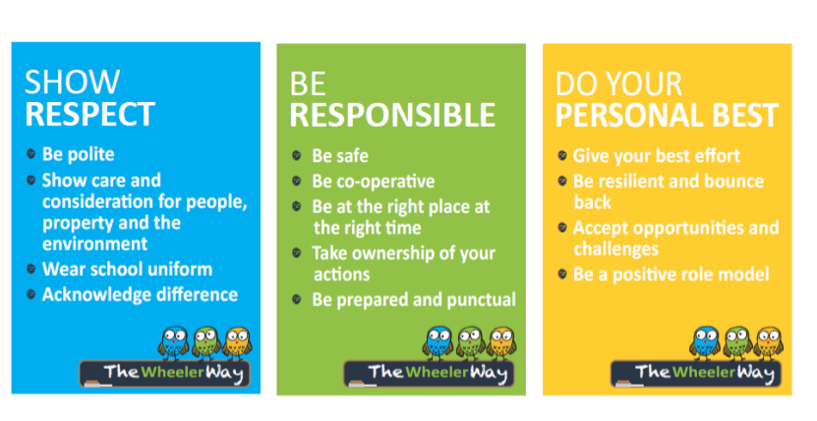
‘The Wheeler Way’

‘The Wheeler Way’ is based on a program from the DEC Northern Sydney Region called ‘Positive Behaviour for Engaged Learning’ (PBEL). PBEL is based based on a long history of behavioural practices and effective instructional design strategies.
In line with PBEL practices our aim is to develop a sustainable and positive school climate and so we have created these three expectations:
Show RESPECT Be RESPONSIBLE Do your PERSONAL BEST
These expectations allow us to:
- Define a clear set of positive expectations and behaviours for the whole school community
- Implement procedures for teaching expected behaviour to encourage positive behaviour while discouraging inappropriate behaviour
- Maximize academic engagement and achievement
- Teach and encourage school-wide positive expectations and acts of respectful and responsible behaviours
- Achieve important social and learning outcomes while preventing problem behavior with all students
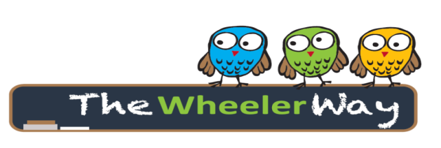
The Wheeler Way provides our school community with a common language and understanding in order to teach, monitor and reward appropriate behaviours.
For enquiries:-
www.wheelerhts-p.schools.nsw.edu.au
Wheeler Heights Public School
36 Veterans Parade
Collaroy Plateau, NSW 2097
Phone : 9971 8352

